Appendix C: IEEE 830 Template
Software Requirements Specification
for
Your Path

Version v2.3
Prepared by Mustafa Cilek
22/04/2026
Table of Contents
«Table of Contents»
Revision History
Name | Date | Reason for Changes | Version
Mustafa Cilek | 04/03/2026 | ”Initial version.” | V1
Mustafa Cilek | 25/03/2026 | ”Added UML Use Case Diagram.” | V1.1
Mustafa Cilek | 07/04/2026 | “Added UML Class Diagram.” | V2
Mustafa Cilek | 14/04/2026 | “Added descriptions to diagrams. Completed Section 1 (Introduction).” | V2.1
Mustafa Cilek | 15/04/2026 | “Added Activity Diagram. Completed Section 2-6.” | V2.2
Mustafa Cilek | 22/04/2026 | “Added State and Sequence Diagram. Fixed the overall document.” | V3
1. Introduction
1.1. Purpose
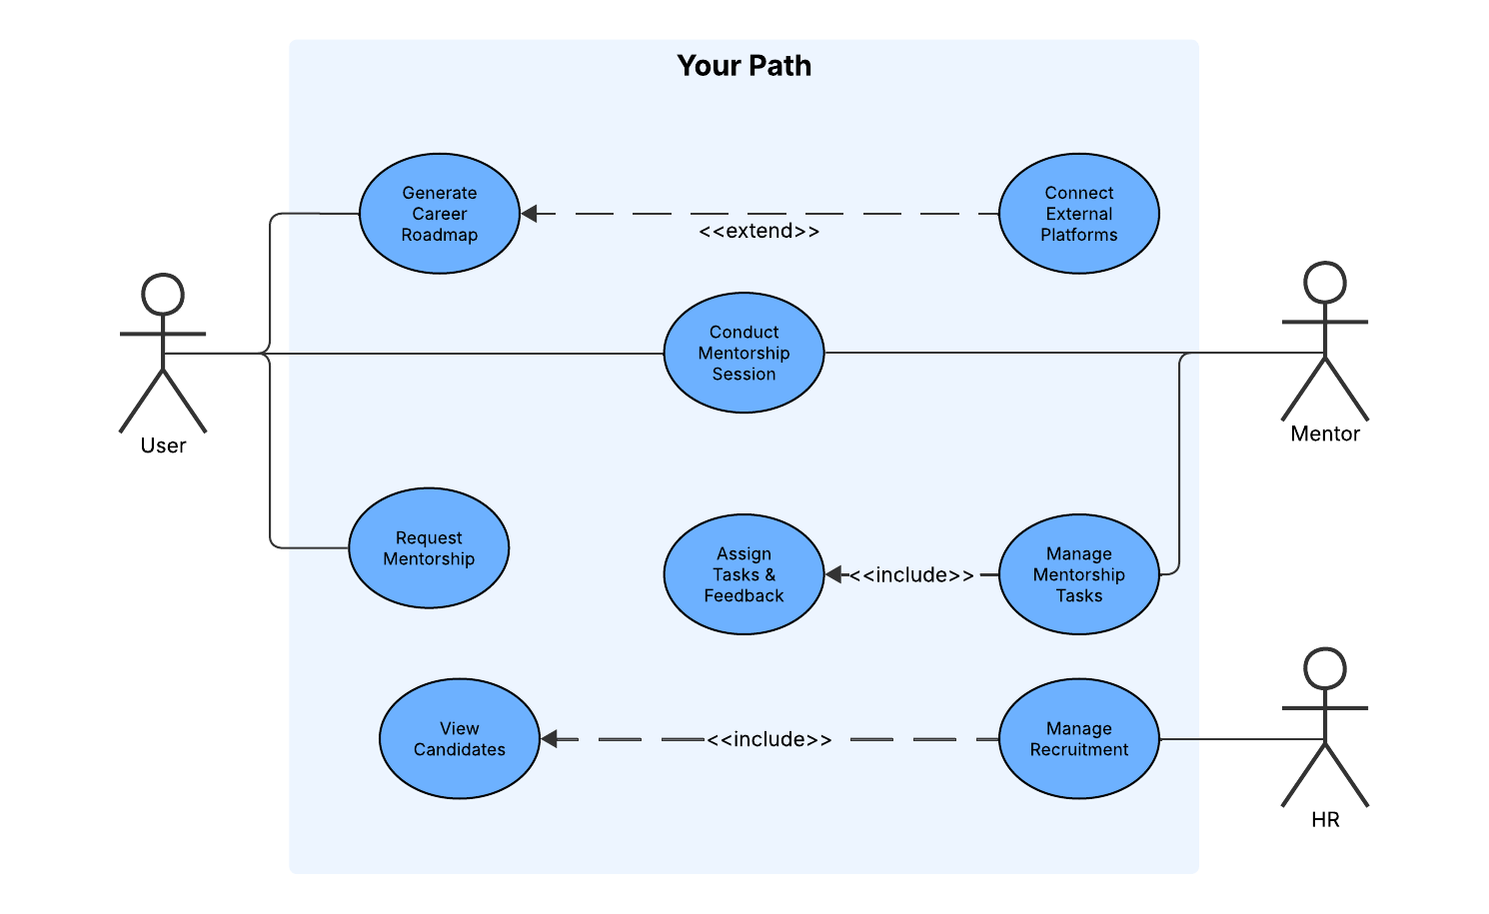
The purpose of this project is to solve a huge problem in today’s job market: students often don't know how their skills fit into the current job market, and recruiters struggle to find verified proof of what a candidate can do. Your Path solves this problem by combining AI-generated career paths with a proper mentorship program. Instead of relying on generic advice that has no relation with the personal data, users get clear, data-driven guidance. At the same time, HR professionals get a hiring platform filled with candidates whose skills are backed and verified by experienced mentors.
To show exactly how people will interact with the platform, this version of the report includes a UML Use Case Diagram. The diagram shows the workflows for our three main actors:
- User (Student/Candidate): They use the app to generate their roadmap, request mentorship, and join sessions. The diagram uses an <<extend>> relationship to show that users can optionally link external accounts (like LinkedIn or GitHub) to get a better, more personalized AI roadmap.
- Mentor: They run the mentorship sessions. The diagram uses an <<include>> relationship to show that managing a mentorship requires the mentor to assign tasks and give feedback.
- HR: They use the platform to manage their hiring.
Overall, the UML use case diagram gives a clear summary of what the system does and how the different users interact with the app.
1.2. Document Conventions
To keep this document easy to read and track, I've used a few simple formatting rules:
Text Styles:
- Bold text: Used for the main system actors (like User, Mentor, HR) and core features.
- Italic text: Used for outside platforms we connect to, like LinkedIn or GitHub.
- Code text: Used for exact UML terms (like <<extend>> and <<include>>).
Requirement Tags: To make things easy for the developers to track, every requirement has a short ID:
- FR-XX: Functional Requirements (e.g., FR-01).
- NF-X.X: Nonfunctional Requirements. The first number is the category (like 1 for speed, 2 for security), and the second is the exact rule (e.g., NF-1.1).
1.3. Intended Audience and Reading Suggestions
This document is written for the development team, QA testers, project managers, and key stakeholders involved in building the Your Path platform.
Here is how the document is laid out and the best way to read it depending on your role:
- Project Managers & Stakeholders: Start with Section 1 (Introduction) and Section 2 (Overall Description). These sections explain the big picture, the core goals, and the user workflows without getting bogged down in technical details.
- Developers & QA Testers: You will need to read the entire document, but your main focus should be on Section 4 (External Interfaces), Section 5 (System Features), and Section 6 (Nonfunctional Requirements). These sections contain the exact rules, constraints, and data structures you need to build and test the software.
It is best to read the document straight through. The high-level diagrams and descriptions in the first few sections will give you the context you need to understand the detailed technical requirements later on.
1.4. Product Scope
Your Path is a web-based platform that combines AI-driven career planning with expert mentorship. Its main goal is to help students figure out exactly what skills they need to land a job, while giving companies a reliable way to find verified talent.
The primary objectives of the system are:
- Personalized Guidance: Generate custom learning roadmaps using AI, based on a user's current skills and linked profiles (like GitHub or LinkedIn).
- Mentorship & Verification: Connect users with industry professionals who can assign tasks, provide feedback, and officially vouch for their abilities.
- Streamlined Hiring: Give HR teams access to a pool of candidates whose skills have been actively vetted by mentors, reducing the risk of bad hires.
From a business perspective, Your Path aims to fix the broken early-career recruitment pipeline. By acting as a bridge between academic learning and industry expectations, the platform reduces hiring costs for companies and accelerates career growth for students.
1.5. References
The following documents and standards were used as a foundation for this specification:
- IEEE Std 830-1998: IEEE Recommended Practice for Software Requirements Specifications.
- Course Assignment: Software Engineering Laboratory Assignment Guidelines, Lodz University of Technology, Spring 2026.
- UML Standard: Object Management Group (OMG) Unified Modeling Language Specification, Version 2.5.1 (used as the standard for the Use Case and Class diagrams).

2. Overall Description
2.1. Product Perspective
Your Path is a brand new, standalone web application. It is not an add-on or a replacement for an older system. Instead, it acts as an independent platform that brings students, mentors, and recruiters together in one unified place.
2.2. Product Features
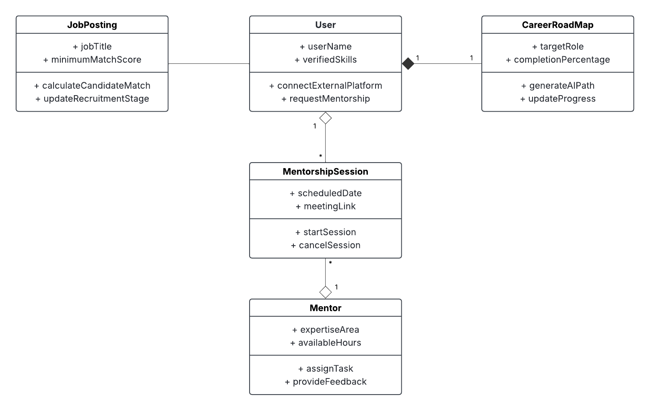
Here are the main features the platform provides, driven by our core system models:
- AI Career Roadmaps: Users can generate custom learning paths for specific target roles and track their completion percentage over time.
- External Integrations: Users can connect outside platforms (like GitHub or LinkedIn) to bring in and verify their skills.
- Mentorship Sessions: Users can request mentorship from professionals based on their expertise. Once connected, they can schedule, start, and cancel live meeting sessions.
- Task Management: Mentors can assign specific tasks to users and provide direct feedback on their progress.
- Recruitment Pipeline: Recruiters can create job postings, let the system automatically calculate a candidate's match score, and update the candidate's stage in the hiring process.

2.3. User Classes and Characteristics
There are three main types of people who will use this platform:
- Students / Candidates: These are early-career users looking for direction. They might not have a lot of work experience, but they are eager to learn. They will use the system the most to check their roadmaps and track tasks.
- Mentors: These are experienced industry professionals. Since they are volunteering their limited time, their dashboard needs to be fast and easy to use for assigning tasks and leaving feedback.
- HR / Recruiters: These users work for companies looking to hire. They care about efficiency and just want to see verified skills and AI match scores at a glance so they can make quick hiring decisions.
2.4. Operating Environment
Your Path is a web-based platform, meaning it just needs a modern web browser (like Chrome, Firefox, Safari, or Edge) to run.
- It must be fully responsive so it works just as well on a phone as it does on a laptop.
- Because the platform includes live mentorship sessions, users will need a stable internet connection and a device with a working camera and microphone.
2.5. Design and Implementation Constraints
We have a few strict boundaries for how this system must be built:
- API Limits: Connecting to external platforms (LinkedIn, GitHub, Kaggle) means we are limited by their API rate limits and data access rules. We have to design our data syncing around those limits.
- Security & Privacy: Because we are handling personal career data and recruitment profiles, all stored data must use AES-256 encryption. We also must comply with standard data protection laws (like GDPR), meaning users need a way to easily delete their accounts and data.
- Tech Stack: The platform must be a responsive web application. The backend must support real-time data updates for the messaging and video call features.
2.6. User Documentation
We want the platform to be intuitive enough that no one needs a massive manual. Instead of a giant PDF, we will provide:
- Interactive Onboarding: A quick, clickable tour that pops up the first time a student, mentor, or HR user logs in.
- Tooltips: Small "info" hover icons placed next to complex features (like the AI match score calculation) to explain how they work.
- Help Center: A simple web page with FAQs, troubleshooting steps for video calls, and a guide on how to link external accounts.

2.7. Assumptions and Dependencies
The success and timeline of this project rely on a few key factors:
- Third-Party APIs: We assume that LinkedIn, GitHub, and Kaggle will keep their developer APIs open and available. If they restrict access or change their data structures, our AI roadmap feature will break or need major rewrites.
- Video Infrastructure: We assume we will use an existing third-party service (like WebRTC or a video API) for the mentorship calls, rather than building a video streaming server from scratch.
- User Hardware: We assume users will have a stable internet connection and a working webcam/microphone for the mentorship sessions.
3. System Features
This section provides a brief overview of the platform's core features. Full technical details for each feature are expanded upon in Section 5.
3.1. AI Career Roadmap Generation
The system uses AI to build a personalized learning path based on the user's target job. Users can optionally link external profiles (like GitHub or LinkedIn) to automatically feed verified skills into their roadmap.
3.2. Mentorship Matching
Users can search a directory of industry professionals based on specific expertise areas. Once they find a match, they can send a direct mentorship request through the platform.
3.3. Mentorship Session & Task Management
Once a mentorship begins, mentors can assign specific tasks and leave feedback. Both users can also schedule and launch live video sessions or text chats directly within the app.
3.4. Recruitment Pipeline Management
HR professionals can post active job openings to the platform. The system automatically calculates a "match score" for verified candidates, allowing recruiters to easily track and move them through the hiring stages.
4. External Interface Requirements
4.1. User Interfaces Overview
The platform features a modern, web-based Graphical User Interface (GUI) designed to be fully responsive on both desktop and mobile devices.
- Student Dashboard: Focuses on the visual AI roadmap, a to-do list for mentor tasks, and a search directory to find mentors.
- Mentor Dashboard: Prioritizes a clean list of active students, upcoming video sessions, and quick-action buttons to assign tasks or leave feedback.
- HR Dashboard: Displays a pipeline view of active job postings and a ranked list of candidates based on their AI match scores.

4.2. Hardware Interfaces
Because this is a web application, there are no custom hardware requirements. Users simply need a standard device (PC, Mac, tablet, or smartphone) with a reliable internet connection. To participate in the live mentorship sessions, the user's device must also have a functional microphone and camera.
4.3. Software Interfaces
The system relies on a few critical software integrations to function:
- External Profile APIs: The system will connect to the APIs of LinkedIn, GitHub, and Kaggle to securely pull in read-only user data for the AI roadmap feature.
- Video Communication API: Instead of building a streaming server from scratch, the platform will use a third-party WebRTC API (like Twilio) to handle the live video and audio for mentorship sessions.
- Database Management System: The backend will connect to a relational database (like PostgreSQL) to securely store user profiles, task histories, and recruitment data.
5. System Features/Modules
5.1. AI Career Roadmap Generation
5.1.1 Description and Priority
Priority: High. This is the core value of the platform. The system generates a personalized, step-by-step career plan based on the user's desired job role and current skills.
5.1.2 Stimulus/Response Sequences
Stimulus: User enters a target job title and clicks "Generate Roadmap."
Response: The system displays a visual timeline of required skills and a completion percentage.
Stimulus: User connects an external platform (GitHub/LinkedIn).
Response: The system scans the profile, marks matching skills as "verified," and automatically updates the roadmap's completion percentage.
5.1.3 Functional Requirements
FR-01.1: The system shall allow users to input a target job title to generate a step-by-step learning roadmap.
FR-01.2: The system shall allow users to securely link external accounts (LinkedIn, GitHub, Kaggle) to import and verify skill data.
FR-01.3: The system shall automatically recalculate and update the user’s overall completion percentage when a new skill is verified or a task is finished.

5.1.4 System Model: Activity Diagram
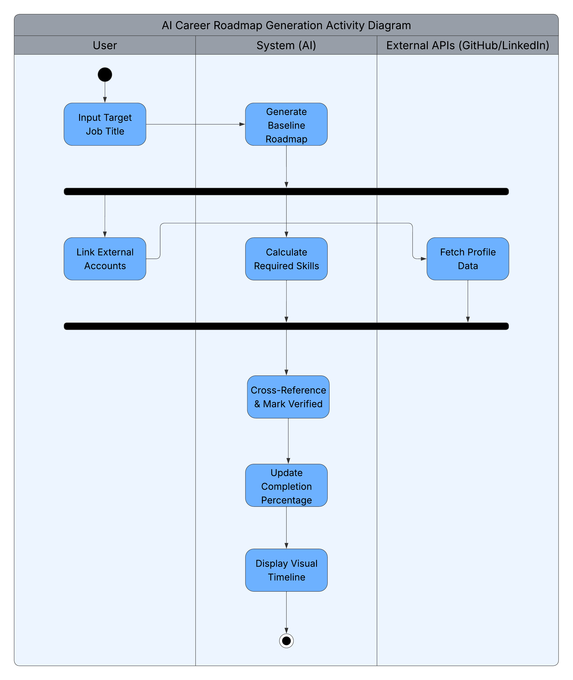
This diagram illustrates the parallel workflows involved in generating a personalized learning path and integrating a user's existing verified skills:
- Initiation: The process begins when the User inputs their target job title. The System immediately responds by generating a foundational baseline roadmap.
- Parallel Processing (The Fork): The workflow then splits into two concurrent tracks. The System begins calculating the specific technical skills required for the chosen role. Simultaneously, the User can link external accounts, which triggers the External APIs to fetch their profile data.
- Synchronization (The Join): Before the system can evaluate the user's current standing, it must synchronize. The workflow waits at a join node until both parallel tasks are complete—meaning the system has finished calculating the required skills and the external profile data has been successfully fetched.
- Cross-Referencing & Completion: Once the data is synchronized, the System cross-references the required skills against the user's fetched profile, marking any existing competencies as "Verified." Finally, the System updates the overall completion percentage and displays the finalized visual timeline to the User.
5.2. Mentorship Matching
5.2.1 Description and Priority
Priority: High. This feature connects students with industry professionals. Users must be able to easily search for mentors based on specific expertise and send requests.
5.2.2 Stimulus/Response Sequences
Stimulus: User searches for a specific skill (e.g., "Python") in the mentor directory.
Response: The system displays a filtered list of mentors who have that expertise area.

Stimulus: User clicks "Request Mentorship" on a mentor's profile.
Response: The system sends a notification to the mentor, moving the request to a "Pending" state.

Stimulus: Mentor accepts the request.
Response: The system creates a new mentorship session and opens a shared dashboard for the two users.
5.2.3 Functional Requirements
FR-02.1: The system shall provide a search and filter interface to browse mentors by their expertise area and availability.
FR-02.2: The system shall allow users to send a formal mentorship request to a specific mentor.
FR-02.3: Mentors shall have a dashboard to view, accept, or reject incoming mentorship requests.

5.2.4 System Model: Sequence Diagram
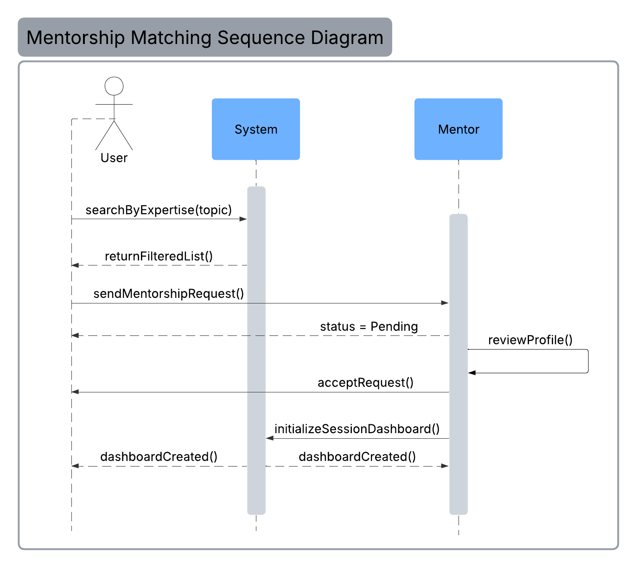
This diagram maps the chronological, step-by-step interactions between a User, the Platform's System, and a Mentor to establish a mentorship connection:
- Discovery: The User queries the System with a specific expertise parameter (e.g., "Python"). The System processes this and returns a filtered list of matching Mentors.
- The Request: The User selects a Mentor from the list and sends a formal mentorship request. The System immediately acknowledges this by placing the request in a "Pending" status on the User's end while it awaits the Mentor's response.
- Approval & Onboarding: The Mentor logs in and independently reviews the User's profile. Upon approval, the Mentor actively accepts the request. This command triggers the System to initialize a new, shared session dashboard, which then simultaneously confirms the successful match to both the User and the Mentor.

5.3. Mentorship Session & Task Management
5.3.1 Description and Priority
Priority: High. This module handles the actual collaboration between the user and the mentor, including task tracking, messaging, and live calls.
5.3.2 Stimulus/Response Sequences
Stimulus: Mentor assigns a new task with a description.
Response: The system updates the user's dashboard and sends an email notification.

Stimulus: User marks a task as "Complete."
Response: The system notifies the mentor to provide feedback and updates the user's roadmap progress.

Stimulus: A user or mentor clicks "Start Video Session."
Response: The system launches the in-app WebRTC video interface.
5.3.3 Functional Requirements
FR-03.1: Mentors shall be able to create and assign weekly tasks to their accepted students.
FR-03.2: Users shall be able to mark tasks as complete and monitor their overall progress via a dedicated dashboard.
FR-03.3: The system shall provide an in-app text messaging interface for active mentorships.
FR-03.4: The system shall support scheduled, live video sessions directly between users and mentors.
5.3.4 System Model: State Diagram
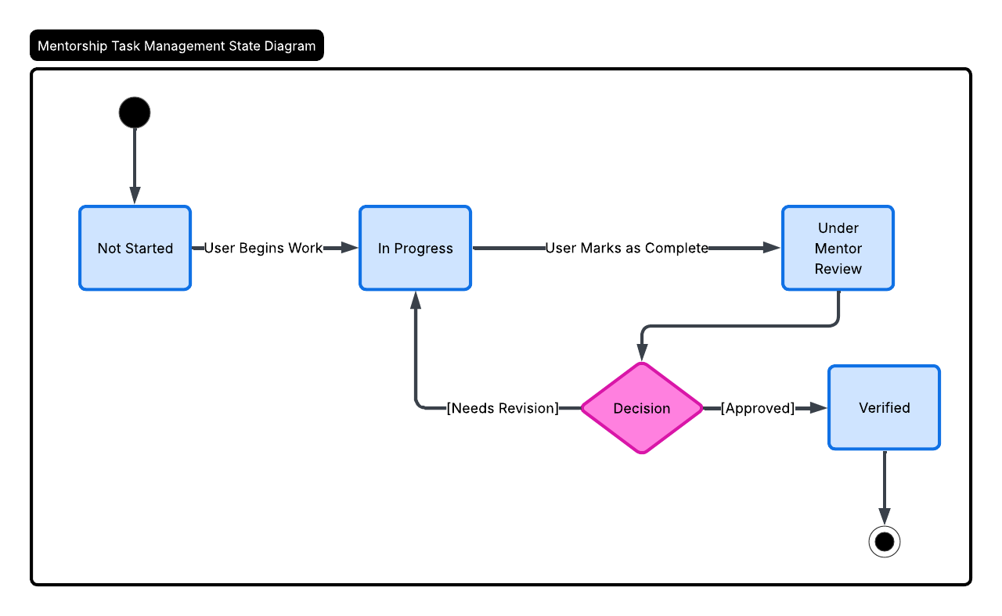
This diagram maps the lifecycle of a specific learning task assigned by a Mentor to a Student:
- Initial State: A newly assigned task enters the system in the Not Started state.
- Active State: Once the user begins work, the task transitions to In Progress. When the user finishes and submits their work, the task moves to Under Mentor Review.
- The Feedback Loop: From the review state, the workflow reaches a decision point based on the Mentor's evaluation:
  - If the work is incomplete or incorrect, the mentor marks it as [Needs Revision], which loops the task back to the In Progress state for the student to try again.
  - If the work meets expectations, the mentor marks it as [Approved], transitioning the task forward to the final Verified state, successfully ending the task lifecycle.

5.4. Recruitment Pipeline Management
5.4.1 Description and Priority
Priority: Medium. This feature allows HR users to leverage the platform's verified data to find and recruit top candidates.
5.4.2 Stimulus/Response Sequences
Stimulus: HR user creates a new job posting with a specific "Minimum Match Score."
Response: The system publishes the posting to the database.

Stimulus: HR user views the applicant list for a job.
Response: The system displays candidates, automatically ranked by their AI Match Score.

Stimulus: HR user changes a candidate's status to "Interview."
Response: The system updates the candidate's recruitment stage and notifies them.
5.4.3 Functional Requirements
FR-05.1: HR users shall be able to create, edit, and manage active job postings.
FR-05.2: The system shall automatically calculate and display an AI Match Score for candidates applying to a job based on their verified skills.
FR-05.3: HR users shall be able to manually update a candidate's recruitment stage (e.g., applied, interview, offer).

6. Nonfunctional Requirements
6.1. Performance
NF-1.1: The system shall load the user dashboard and career roadmap within 2 seconds under normal network conditions.
NF-1.2: The platform must support at least 1,000 concurrent video sessions without degradation in audio or video quality.
6.2. Security
NF-2.1: All user data, including integrated profile data from LinkedIn or GitHub, must be encrypted at rest and in transit using AES-256.
NF-2.2: The system shall use Two-Factor Authentication (2FA) for all HR and Mentor accounts to protect sensitive recruitment and personal data.

